Event Driven Models

There are 2 models which are widely used

1. Pub/sub model
2. 2) Event stream model

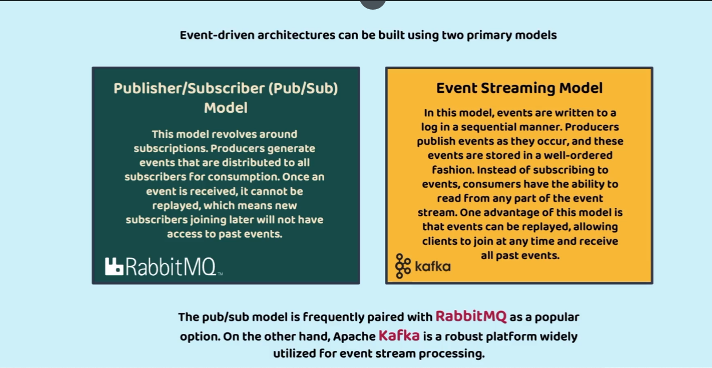

First will go through the Pub/sub model consider a scenario where an account microservice will be creating an account and same will be published to an event broker. The services registered to the event broker receives the notification from broker then process the data and an email messages will be sent to customer. Once message and email are sent then we also have to update in the DB about the communication sent to customer this process is known as reverse asynchronous communication. Here communication between message microservice and accounts microservice is asynchronous

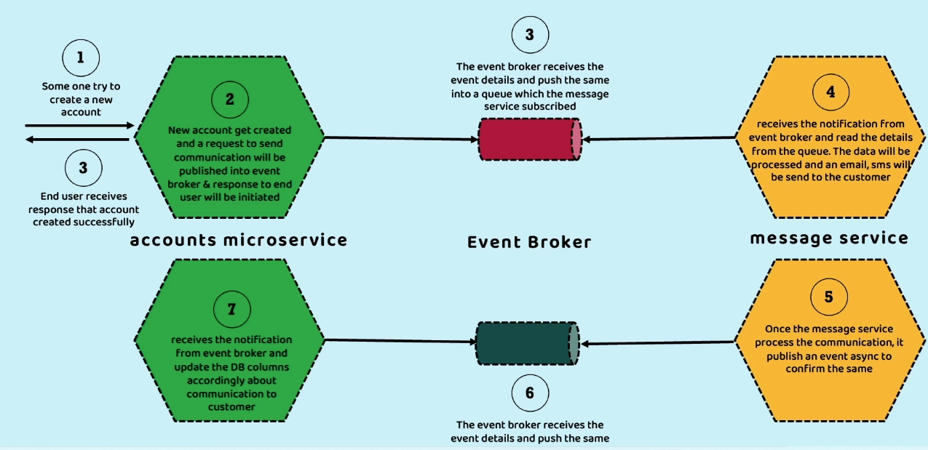

Lets achieve this by RabbitMq it is a light weight message broker it follows the pub sub model where past events are not stored

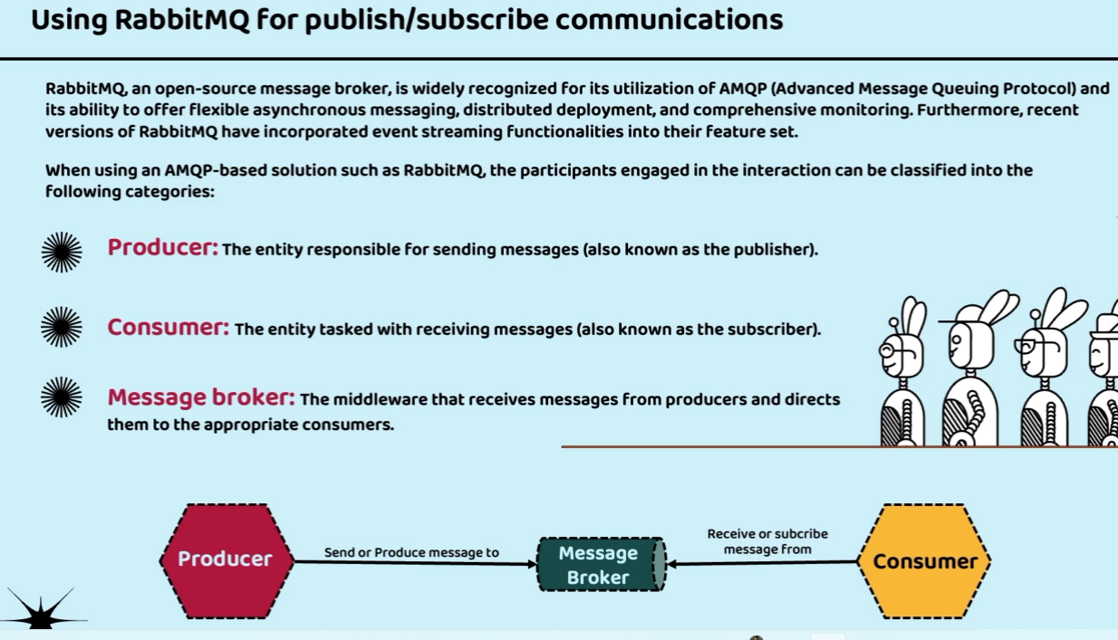

Internally message broker contains exchanges and queues whenever producer produces the events then first it is processed by exchange then depending upon information it then passes it to the queues. And any number of receivers can be subscribed to these queues

